Datasafe_Private_Endpoint with ORM stack

Contents

1. Introduction 3
2. Workflow diagram to deploy the stack 3
3. Create stack for Datasafe private endpoint 4
4. Plan the Job 6

Introduction

When registering a target database with Oracle Data Safe, a common connection is through an Oracle Data Safe private endpoint. Databases that support connection through a private endpoint include the below with a note stating which databases recommend the private endpoint.

Workflow diagram to deploy the stack

Below diagram shows how the Terraform Artifact are applied in the OCI. While creating a ORM stack, using terraform deliverables Init, Plan and Apply is the flow to provision the resource in the OCI. We can have the deliverables in any of below.

- GitLab/GitHub Repo
- Bitbucket
- Can be in folder/.zip in the local disk
- Object Storage Bucket
- Can be in compartment
- Oracle provided Template


Create stack for Datasafe private endpoint

Go to OCI Console Developer Services Resource Manager Stacks select the compartment Create Stack

My Configuration Folder Browse Select the “datasafe_private_endpoint” folder that contains the terraform Upload

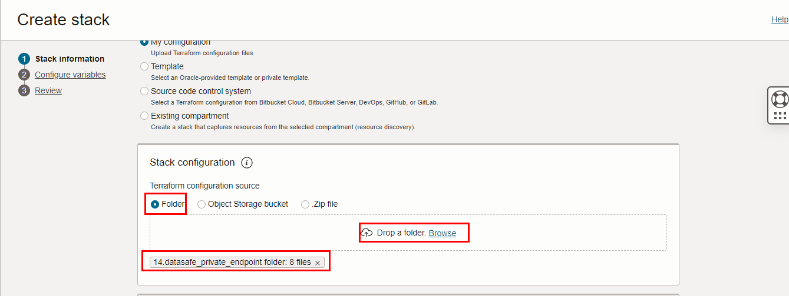

Select the parameters as per the below screen,
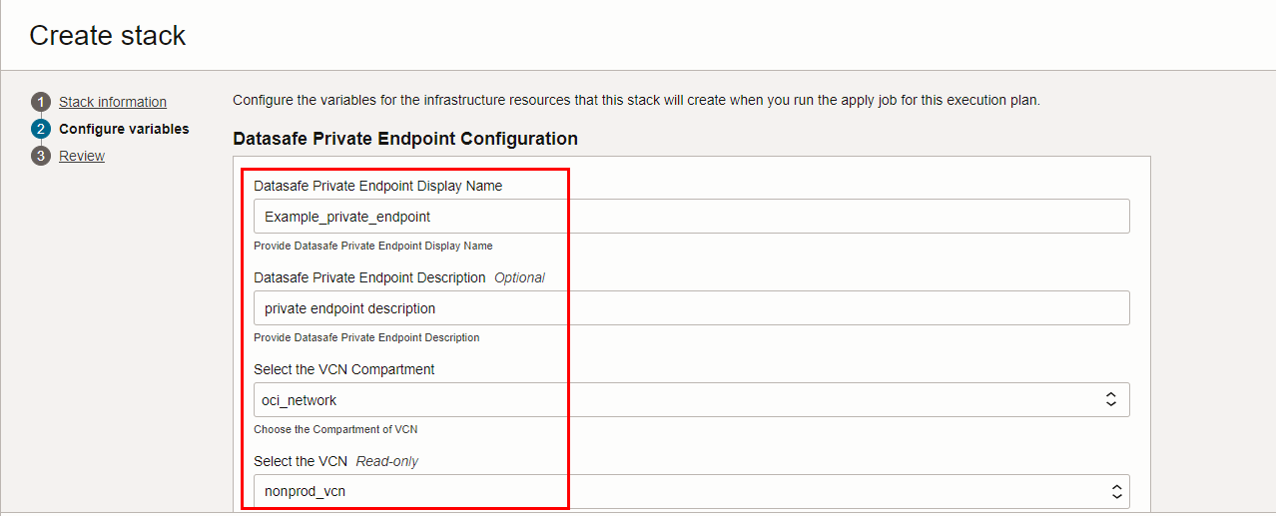

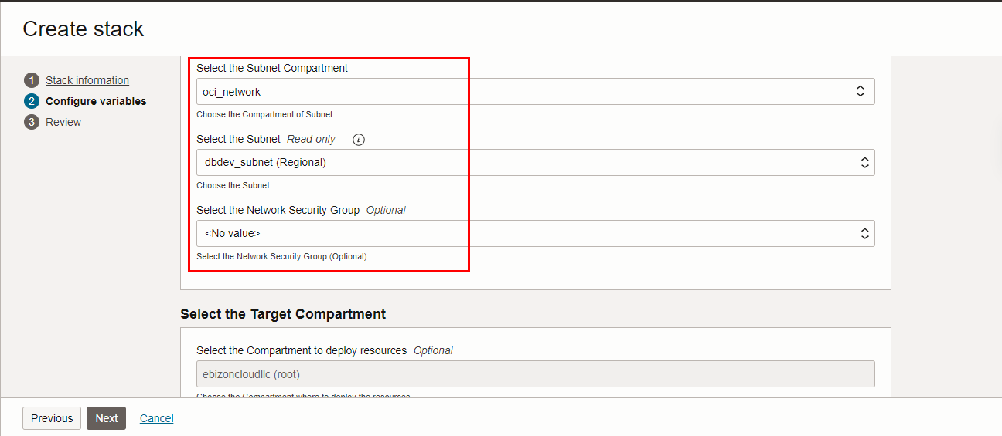

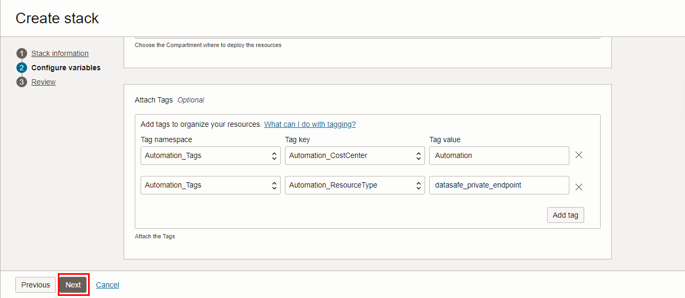

Click “NEXT”
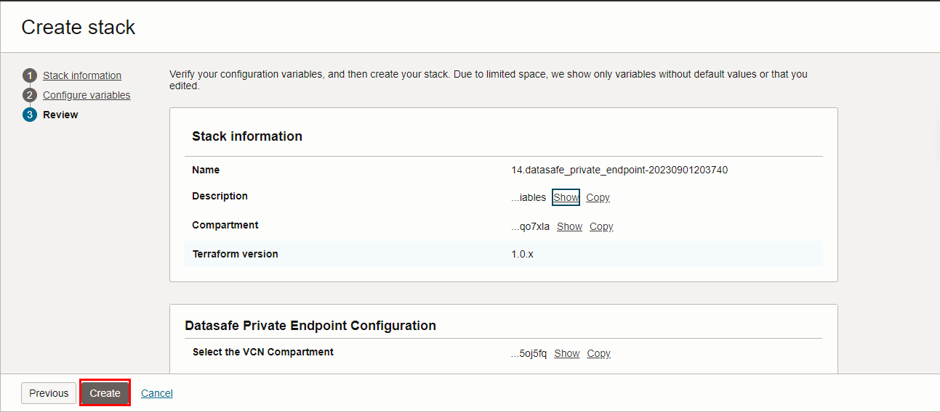
Click “CREATE”

Plan the Job
Click the “Plan”
